domain Analysis(FDA)

Time domain Analysis(TD)

DC Measurement(DC)

Combination(Comb)

Analog front-end (AFE)

# 1 Client application system

This client application system includes a client application program, Web APP, and a network server to match the microcontroller and the signal are acquired from an analog front-end (AFE) designed chip.

## 1.1 Client application

### 1.1.1 Framework of the EIS-Client application

The client application has 3 main functions, Through this app users can create a new project, load an old project and analyse the existed data.The Framework is shown in Figure 1 below:



**Figure 1:** TheFramework of the EIS-client application

There are 4 attributes in a project, When users create a new project, the system will open a new form as figure 2, named “NewProject”, in this form users can input the Project Name, Folder Path and Description for the project. At the same time, the system will automatically create an ID number for the project, which is used to be identified by Web Server, microcontroller and EIS-client application itself.

In the Folder Path, a Folder with the Project Name will be created. The folder has also 4 folders, FDA, TD, DC, Comb, which are used to store the data of experiment and pictures of curves.

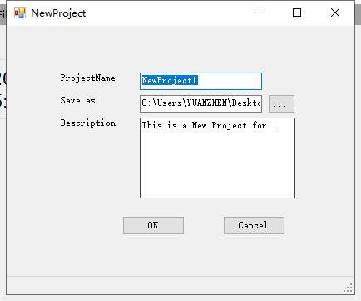

**Figure 2:** The Form, NewProject

When users select project(New Project or Load Project), they should select the parameters for COM and Sever, then connect with microcontroller by serial port and Web Server by Wi-Fi to ensure communication wit each other.After that, 4 models, Frequency domain Analysis (FDA), Time domain Analysis (TD), DC Measurement (DC), Combination(Comb), can be selected by users.

When users select Data Analyzer, they can plot the curves of FDA, TD, DC, Comb from historical data.

The following figure 3 described the processes of the client application:



**Figure 3:** The Flow Chart of the EIS-client application

Each models has a start and a stop button:when users click the start button, client application will send parameter to microcontroller, then the experiment starts; When users click the start button, the experiment will be disturbed right away.

### 1.1.2 Configuration

In the interface of Configuration there 2 main parts, Serial COM and Server Configuration, the figure 4 and figuration are shown blow:

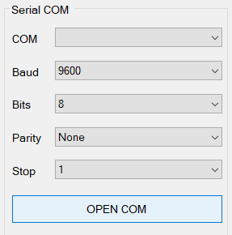

**Figure 4:** Serial COM

Due to communicate with microcomtroller successfully, this client application adapted to serial port, this port has 4 attributes as above figure 5, COM, Baud, Bits, Parity, Stop.

When the client application connects with microcomtroller successfully and microcomtroller is unused, the message box will show “MCU is already!”;

When the client application connects with microcomtroller successfully but microcomtroller is working, the message box will show “MCU is busy!”;

When the client application connects with microcomtroller unsuccessfully, the message box will show “False COM!”.

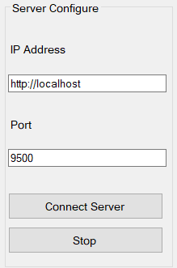

**Figure 5:** Server Configuration

Due to communicate with Web Server successfully, this client application used TCP protocol, this Web Server has 2 attributes as above figure 5, IP Address, Port.

When the client application connects with Web Server successfully, the message box will show “connect server successfully”.

### 1.1.3 Frequency domain Analysis(FDA)

In this Interface, users can operate 2 areas, AC Control as figure 6 and Experiment Control as figure 7, and see the Real-time curve plot zone as figure 8 , this function can show the Bode Diagram includes Amplitude-Frequency curve and Phase-Frequency curve, as well as Nyquist Diagram.

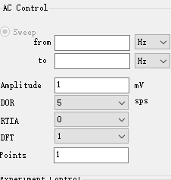

**Figure 6:** AC Control of FDA

In this part, users can set the parameters for Sweep Frequency, Amplitude, DOR(data output ratio), RTIA, DFT and Sweep Points.

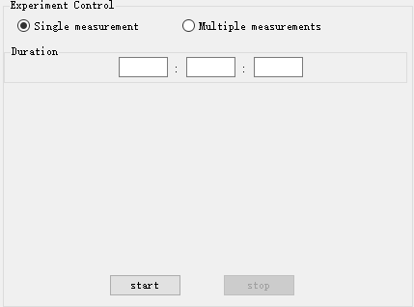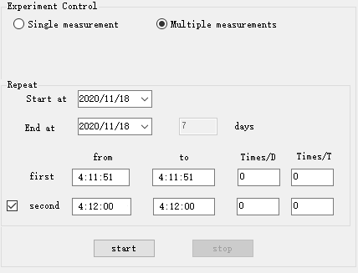

**Figure 7:** Experiment Control: Single measurement(Above), Multiple measurement(Below)

In this part, users can select 2 models, Single measurement and Multiple measurement:

**Single measurement:** Users can set the time from 0 second to 86400s, but mostly not more than 5 min.

**Multiple measurement:**Users can set the period, but not more than 7 days.They also need to set the begin time, end time, Measure times for the first period and repeat times for each Measurement. When users want to continue the experiment after a short pause, they can check here and set the parameter as the first period.But the stop time should not more then 24 hours.

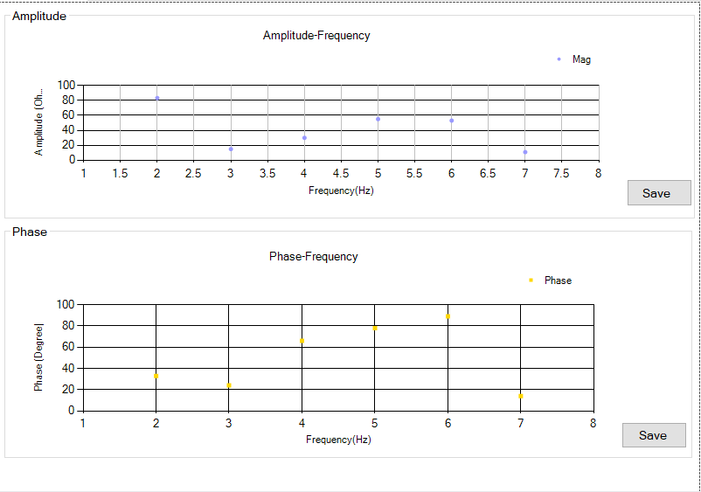

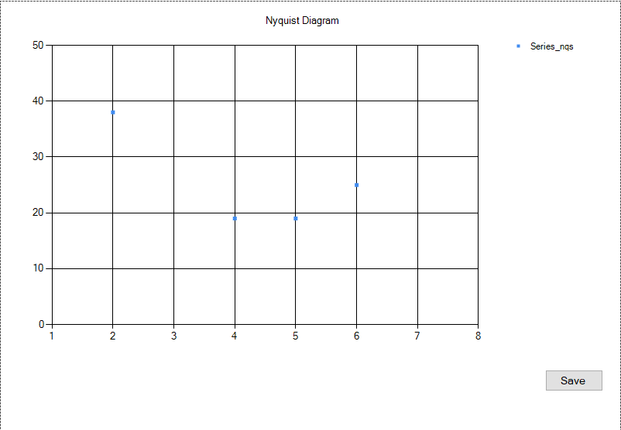

**Figure 8:** Plot zone: Bode Diagram(Above), Nyquist Diagram(Below)

In this part, Real-time curves will be drawn in the plot zone. Users can store curves as well, Amplitude-Frequency curve named as “bode_amp.png”, Phase-Frequency curve named as “bode_pha.png”, Nyquist curve named as “Nyqst.png”. All of the pictures are saved in FDA folder, when the pictures are saved, the message box will show “you have stored this picture”.

Following is the list of Ranges of parameters in FDA:

Sweep from: <200kHz

to:      <200kHz

Amplitude:  <607 mV

ODR:     1-200 sps

RTIA:     0-8

DFT:     0-12

Sweep:    0-200 Points

Single_m:   True/False

Multiple_m: False/True

Duration_h: <24

Duration_m: <60

Duration_s: <60

Start_Datum: xx/xx/xx

End_Datum:  xx/xx/xx

Repeat:    0,1-7 days

From:     xx:xx:xx

to:       xx:xx:xx

repeat:    0-5 Times/day

repeat:    0-5 Times/Cycle

Second:   False

From:     xx:xx:xx

to:      xx:xx:xx

repeat:    0-5 Times/day

repeat:    0-5 Times/Cycle

### 1.1.4 Time Domain Analysis(TD)

In this Interface, operations is similar to Frequency domain Analysis, but in Time Domain Analysis users can only select Single measurement. Users can also operate 2 areas, AC Control as figure 9 and Experiment Control as figure 7 (above), and see the Real-time curve plot zone as figure 8 as well.

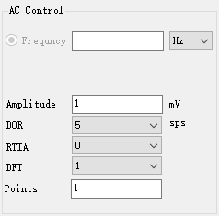

**Figure 9:** AC Control of TD

The difference in this part to FDA is that user can only set a fest frequency.

Also, the Experiment Control of TD is same as FDA (above).

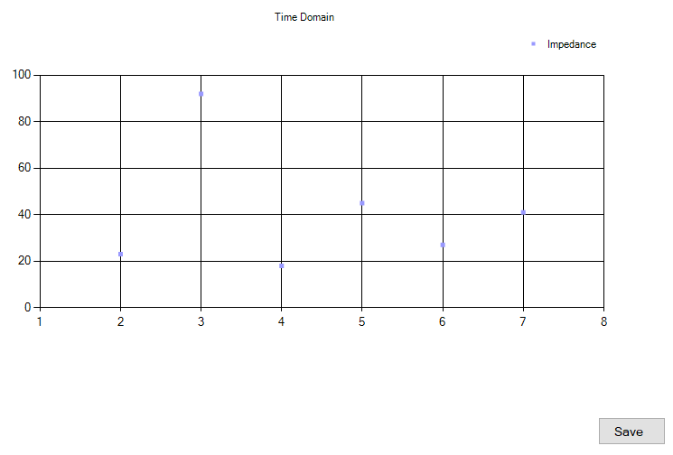

**Figure 10:** Plot zone: Time-Impedance curve

Here in the Figure 9, the chart display the relationship between time and Impedance. Users can store curves as well, Time-Impedance curve named as “TD_Wave.png”. All of the pictures are saved in TD folder, when the pictures are saved, the message box will show “you have stored this picture”.

Following is the list of Ranges of parameters in TD:

Frequency:  <200 kHz

Amplitude:  <607 mV

ODR:     1-200 sps

RTIA:     0-8

DFT:     0-12

Sweep:    0-200 Points

Single_m:   True

Duration_h: <24

Duration_m: <60

Duration_s: <60

### 1.1.5 DC Measurement (DC)

In this Interface, there are 2 parts, that users can operate, DC Control as figure 11 and U-I-R as figure 12, and see the Real-time curve plot zone as figure 12 as well.

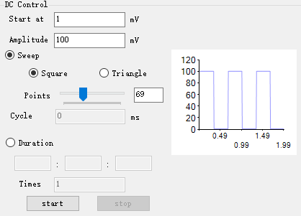

**Figure 11:** DC Control

This part has also 2 models, Sweep model and Duration model.Before users choose the model, they should set start voltage and peak voltage.

**Sweep model:** At first, users should select Sweep waves(Square wave or Triangle wave), then set the sweep points. In the right chart, users can preview the wave, and also know the Cycle of the wave.

**Duration model:** Users can set the time from 0 second to 86400s, but mostly not more than 5 min.And they can set repeat times for each Measurement.

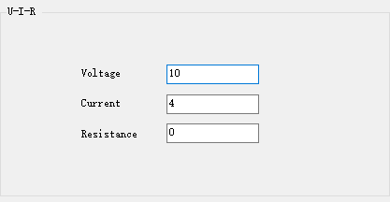

**Figure 12:** Real time data(Voltage, Current, Resistance)

In figure 12, it shows the Real time status of Voltage, Current, Resistance.

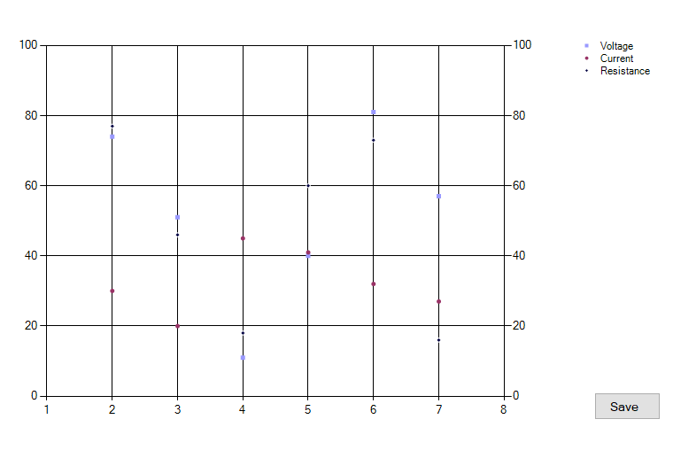

**Figure 13:** Real time curve (Voltage, Current, Resistance)

In figure 12, it shows the Real time curve of Voltage, Current, Resistance in a chart.

Users can store curves as well, U-I-R curve named as “U_I_R_Wave.png”. All of the pictures are saved in DC folder, when the pictures are saved, the message box will show “you have stored this picture”.

Following is the list of Ranges of parameters in DC:

Strat at:   <607 mV

Amplitude:  <607 mV

Sweep:    True/False

Square:    True/False

Triangle:   False/Ture

Sweep:    0-200 Points

Duration:   False/True

Duration_h: <24

Duration_m: <60

Duration_s: <60

repeat:    0-5 Times

### 1.1.6 Combination(Comb)

In the Combination Interface, there are 3 steps: AC Control as figure 14, DC Control as figure 15, Temperature Measurement as figure 16. The plot zone is same as FDA, figure 8.

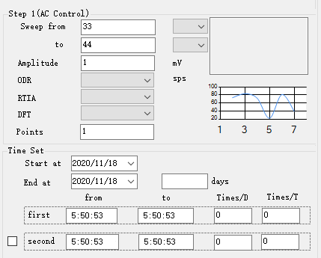

**Figure 14:** Step1(AC Control) and Time Set

In the step 1, user operate the same as Multiple measurement in FDA. Besides, the right text box and chart can show the temperature of the experiment.

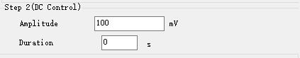

**Figure 15:** Step2(DC Control)

In the step 2, users need only to set the peak amplitude of DC signal and the time of duration, this time is always very short, often as 5-30s.

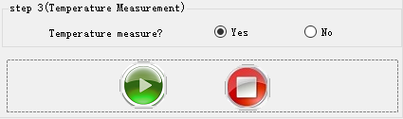

**Figure 16:** Step3(Temperature Measurement)

In the step 3, users have only to choose, if the experiment measure temperature.

The plot zone of Combination is the same of FDA, users can alse store curves, Amplitude-Frequency curve named as “bode_amp.png”, Phase-Frequency curve named as “bode_pha.png”, Nyquist curve named as “Nyqst.png”. All of the pictures are saved in Combination folder, when the pictures are saved, the message box will show “you have stored this picture”.

Following is the list of Ranges of parameters in Combs:

Sweep from: < 200 kHz

to:      <200 kHz

Amplitude:  <607 mV

ODR:     1-200 sps

RTIA:     0-8

DFT:      0-12

Sweep:    0-200 Points

Start_Datum: 2020/xx/xx

End_Datum:  2020/xx/xx

Repeat:    1-7 days

From:     xx:xx:xx

to:      xx:xx:xx

repeat:    0-5 Times/day

repeat:    0-5 Times/Cycle

Second:   true/False

From:     xx:xx:xx

to:       xx:xx:xx

repeat:    0-5 Times/day

repeat:    0-5 Times/Cycle

Amplitude:  <607 mV

Duration_s: 0-255

Tempe/yes:   True/False

Tempe/no:   False/True

### 1.1.7 Data Analyzer

When users select Data Analyzer, this system will show the data from .txt file in the selected project.The blew figure 17 is the menu of Data Analyzer.

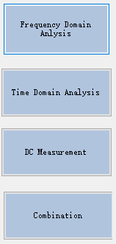 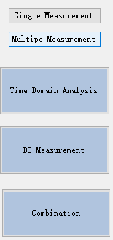

**Figure 17:** The menu of Data Analyzer

The FDA hat also 2 model, Single Measurement and Multiple Measurement. And plot zones are same as the plot zones of experiment.

### 1.1.8 Other areas

#### 1.1.8.1 Main menu

When users click the File(F), they can see a drop list as figure 18.

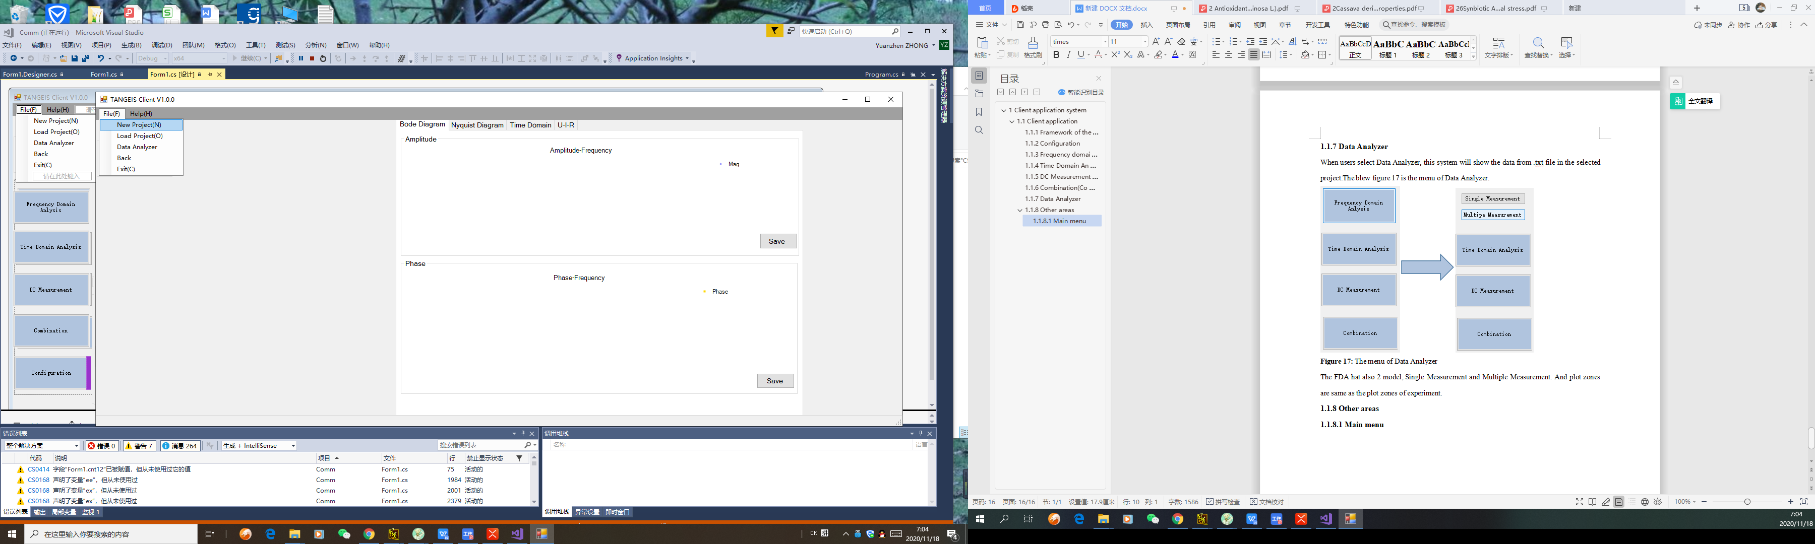

**Figure 18:** Drop list of Main menu

Once users select a function of New project, Load Project or Data Analyzer, “Back” and other 2 function can not more be used. Only when the experiments are stop, users can select “Back”

, then can select all the functions.again. “Exit(c)” can shut the client application down.

#### 1.1.8.2 Time Display

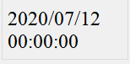

**Figure 19:** Time Display

Figure 19 can always show time.

#### 1.1.8.3 Data Received Area

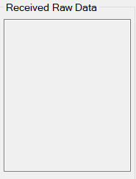

**Figure 20** Data Received Area

This Textbox always show the raw data from microcotroller.